# Homework: CSS-Overview

## World Cup Brazil

Create a HTML page like the image below. **100% accuracy is required.** Use **external CSS file** for the styles. Button images and flag images must be **linked through the CSS file**.

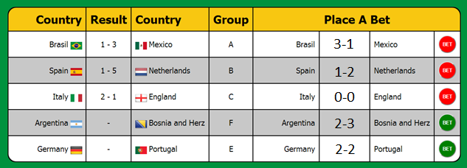

## Color Kitchen

You are given an HTML file ***ColorKitchen.html*** and ***result.png***. Apply styles to the html file and make it look like the result.png (the last image below). **100% accuracy is required.** Use **external CSS file** for the styles. You are given the background image as well.

Make the menu hover as in the following images (the link for an article must hover with the color of the article’s header). Visited links must be gray. Not visited links must be black, as shown in the pictures above (“Web Safe Colors” is not visited, “Lorem Ipsum” is visited).

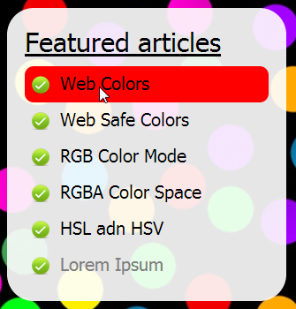 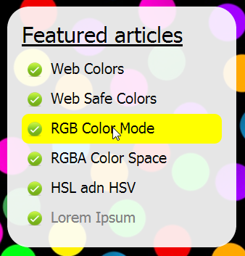

**Constrains:** You are NOT allowed to change the HTML file. Do not use an image for the header of the page!

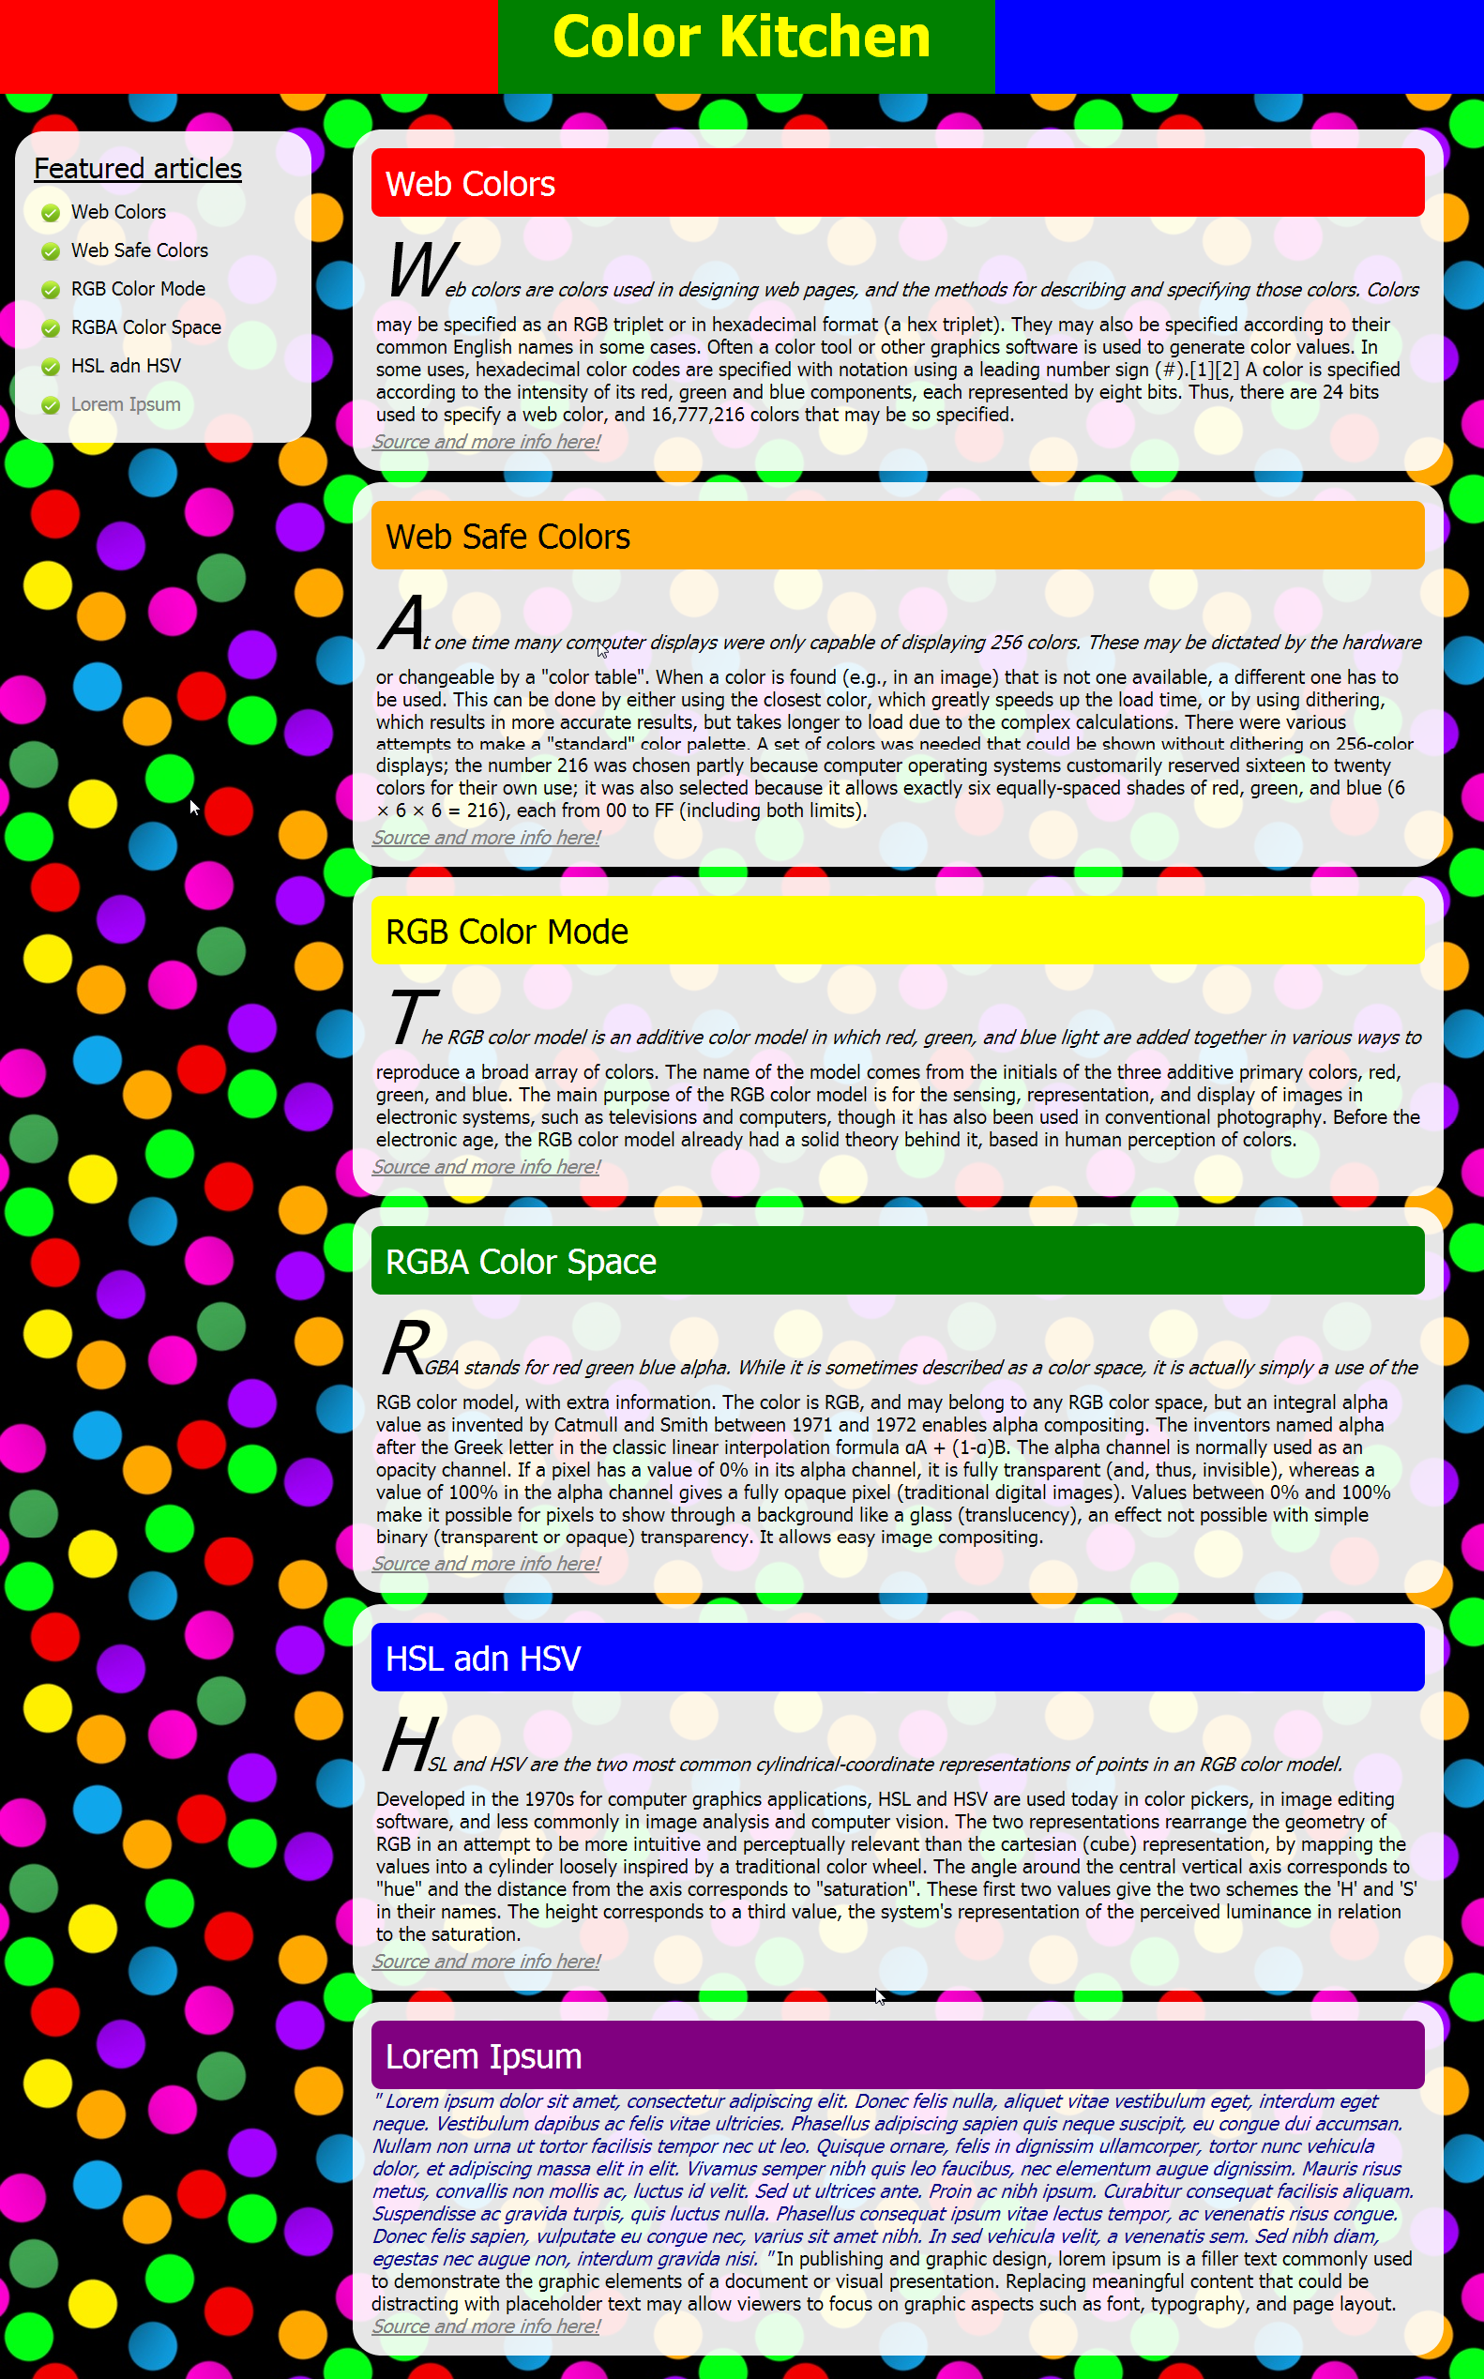

## *FMI Student Before Exam

Create a HTML page like the image below. **100% accuracy is required.** Use only **<div>**s. Use **external CSS** file for the styles. You might need to use CSS absolute positioning.

